ATHENA - AUTONOMOUS TRIAGE AND HEALTHCARE ELECTRONIC NEURAL ASSISTANT
Methodology, Novelty and Key Contributions
Department of Computer Science and Engineering, TKR College of Engineering & Technology
Batch A7 (CSE-A) · Academic year [ACADEMIC YEAR]
Table 1: Project team
S.No. | Student name | Roll number
1 | Badaveni Srinath | 23K91A0523
2 | Basani Avinash | 23K91A0532
3 | Degala Praneeth | 23K91A0561
4 | Bontha Saisree | 23K91A0545

Project guide: K. Shalini
Chapter and section numbers quoted in the text (for example Chapter 8 or Section 6.2) refer to the full project report, 17.Final Document. Figures and tables in this document are numbered from 1.

1. METHODOLOGY
This document describes how ATHENA works from end to end and what is new in it. Part 1 gives the pipeline, the data, the algorithms and the reasons they were chosen; Part 2 sets the work against the base paper and separates what is new from what is standard; Part 3 lists the contributions. All model results are on seeded synthetic data.

1.1 Overall methodology
ATHENA was built in eight stages, each producing a file or a measurement that the next stage uses. The stages are the same for the documents and for the code, so every claim in this report can be traced to a script.
Table 2: Stages of the methodology
Stage | What is done | Output
1 Problem framing | read the batch objectives and the base paper; decide the target (five-level priority) and the inputs (report + vitals) | 36-input fused record, priority 1 to 5
2 Data | generate a seeded synthetic dataset of 6,000 patients (no real records were available) | data/sample/triage_synthetic.csv
3 Report reading | PDF text layer or local OCR, then a clinical lexicon with negation and lab limits | 28 report flags with page numbers
4 Fusion | append the eight vitals to the flags in a fixed column order | one record per patient
5 Model | train XGBoost, calibrate its probabilities with isotonic regression on a separate split | models/triage_model.joblib
6 Explanation | SHAP tree attribution for the chosen priority, strongest first | per-patient factor list
7 Serving | FastAPI services, SQLite storage, React screens, clinician accept-or-change loop | running application
8 Evaluation | hold-out metrics, model comparison, ablation, calibration, robustness, reader stress test, tests and timing | experiments/**/metrics.json

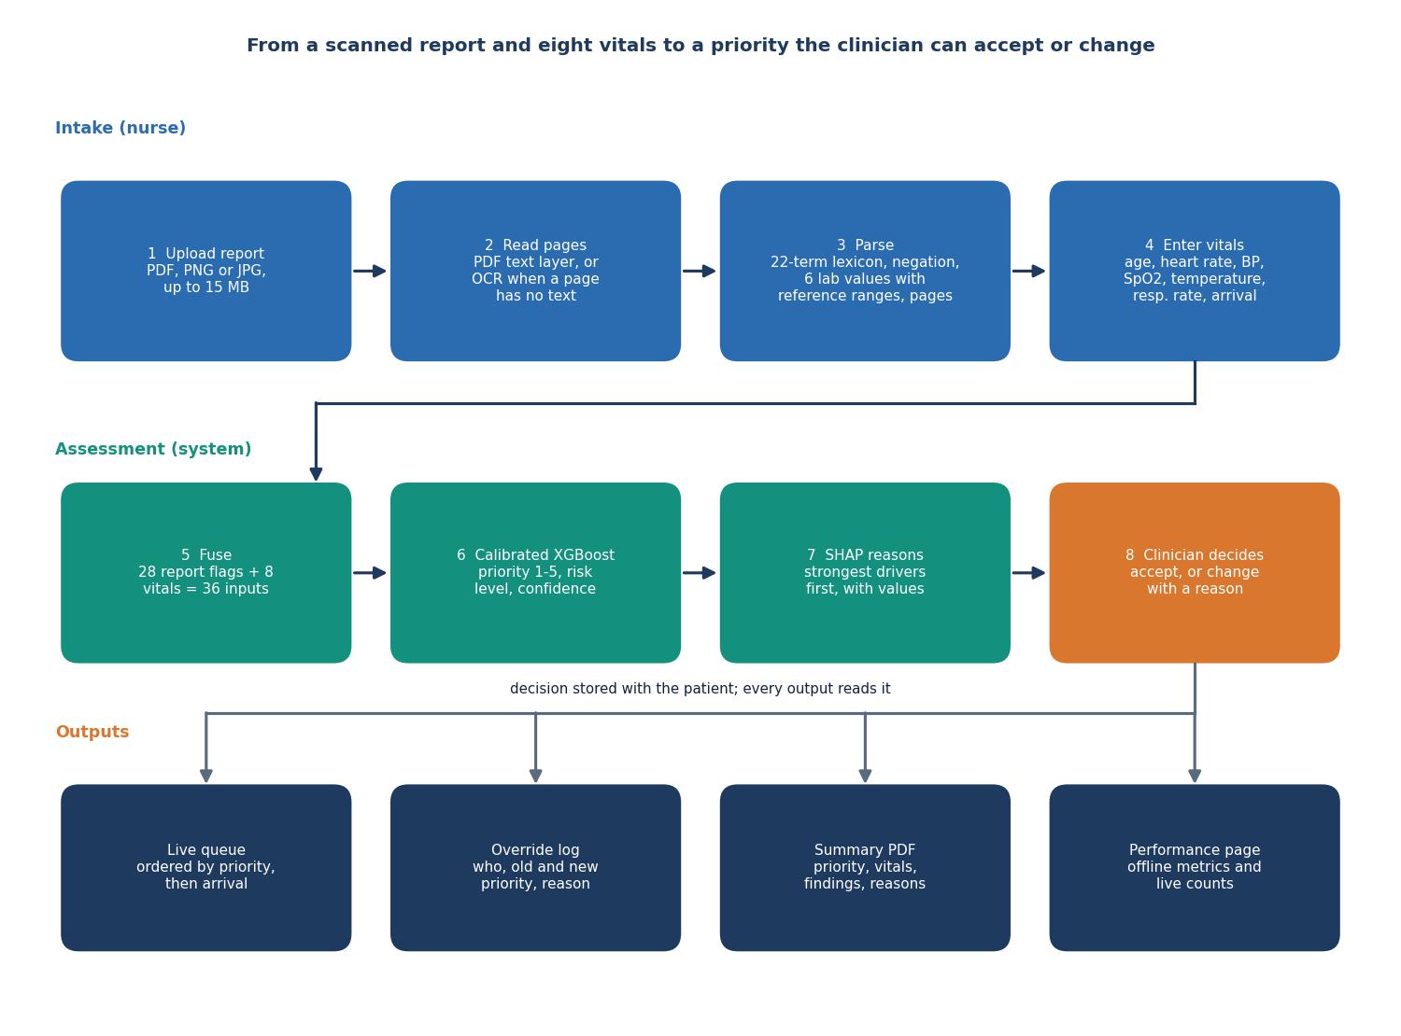
Figure 1: Overall workflow of ATHENA from a scanned report and vitals to a clinician-approved priority.
The methodology follows the base paper in three respects: several algorithms are compared on the same split before one is chosen, a probability (not only a label) is reported together with a confidence threshold analysis, and a symptom that is not documented is treated as absent without imputation [1]. It departs from the base paper in the input (a scanned report fused with vitals instead of a typed symptom checklist), in the target (five triage priorities instead of ICD-10 diagnoses) and in the data (synthetic, where the base paper uses real clinical records).

1.2 Dataset

1.2.1 Why the data is synthetic
The batch plan named a public Kaggle dataset of hospital triage and patient history records. Accessing it needs a personal Kaggle token and its licence is not stated, so it was not used; the download script scripts/download_data.py exists but was never run or tested. The model is therefore trained on a seeded synthetic dataset, and every accuracy figure in this report is measured on that synthetic data. It measures how well the model recovers a known rule, not how well it agrees with clinicians.

1.2.2 How the dataset is generated
ml/make_data.py (seed 7307) simulates 6,000 patients. For each patient an archetype is drawn, then age, vitals, report flags and the arrival mode are sampled from that archetype, a severity score is computed from clinical rules, Gaussian noise is added, and the score is cut into a priority. The priority plays the role of the clinician-recorded outcome.
Table 3: Clinical archetypes (shares are measured on the generated data)
Archetype | Share | Report flags and their probability | Vital shifts (HR, SBP, SpO2, T, RR)
minor | 33.6% | fever .12, trauma .12, hypertension .15, vomiting .08, abdominal pain .08, diabetes .08 | none
cardiac | 14.6% | chest pain .80, dyspnoea .35, ST elevation .22, troponin raised .35, cardiac history .50, hypertension .50 | +8, +5, -1, 0, +2
respiratory | 11.9% | dyspnoea .90, fever .40, infiltrate .40, COPD .50, WBC raised .30 | +10, 0, -5, +0.5, +7
neuro | 8.5% | stroke signs .50, headache .45, altered mental state .35, haemorrhage on CT .12, hypertension .60 | 0, +22, -1, 0, +1
trauma | 11.7% | trauma .95, fracture .45, bleeding .35, Hb low .12, free fluid .08 | +12, -6, -1, 0, +3
infection | 9.4% | fever .85, WBC raised .65, lactate raised .22, altered mental state .15, diabetes .25 | +18, -12, -2, +1.4, +5
abdominal | 10.3% | abdominal pain .95, vomiting .55, WBC raised .30, fever .20, free fluid .12 | +8, -3, 0, +0.3, +2

Vitals are drawn from normal distributions and clipped to physical limits: age from a gamma distribution (shape 4.2, scale 11, plus 3, clipped to 1-98), heart rate N(82 + shift, 14), systolic pressure N(124 + shift + 0.25 (age - 45), 17), SpO2 N(97.5 + shift, 2), temperature N(36.8 + shift, 0.5), respiratory rate N(16 + shift, 3), and diastolic pressure 0.62 times systolic plus N(0, 7). The arrival mode is walk-in, ambulance or transfer with probabilities .55 / .35 / .10 for minor and abdominal patients and .25 / .60 / .15 for the others. A flag that an archetype does not list has probability .01 (.02 for the six lab flags, .06 for hypertension and diabetes).

1.2.3 The severity rule and the labels
The severity score s is the sum of the terms below plus a weight for each report flag that is present; noise from N(0, 0.4) is added, and s is cut into priorities.
Table 4: Severity score terms
Term | Contribution to s
Heart rate | +2 above 130; +1 above 110; +1.5 below 45
Systolic pressure | +3 below 90; +1.5 below 100; +1 above 180
SpO2 | +3.5 below 90; +1.5 below 94
Temperature | +1.5 above 39.5 or below 35; +0.7 above 38.3
Respiratory rate | +2 above 28; +1 above 22
Age and arrival | +0.8 above 75; transfer +0.5; ambulance +0.8
Report flags (weight each) | ST elevation 4, haemorrhage on CT 4, focal weakness 3, altered mental state 2.5, troponin raised 2.5, lactate raised 2.5, free fluid 2, dyspnoea 1.5, syncope 1.5, bleeding 1.5, chest pain 1.2, trauma 1, infiltrate 1, glucose abnormal 1, Hb low 1, fracture 0.8, severe headache 0.8, creatinine raised 0.8, WBC raised 0.7, abdominal pain 0.6, cardiac history 0.5, anticoagulant 0.5, COPD 0.4, fever 0.4, diabetes 0.3, prior stroke 0.3, hypertension 0.2, vomiting 0.2

priority = 1 if s ≥ 8; 2 if 5.2 ≤ s < 8; 3 if 3.0 ≤ s < 5.2; 4 if 1.2 ≤ s < 3.0; 5 otherwise (1)
The generated priorities are 5.5% / 19.9% / 26.1% / 26.7% / 21.8% for priorities 1 to 5. The label noise has a consequence that matters when the results are read: a model that knew the exact severity score would still disagree with the stored label on 13.7% of the rows, so exact accuracy cannot exceed about 86.2% on this data (Chapter 8).
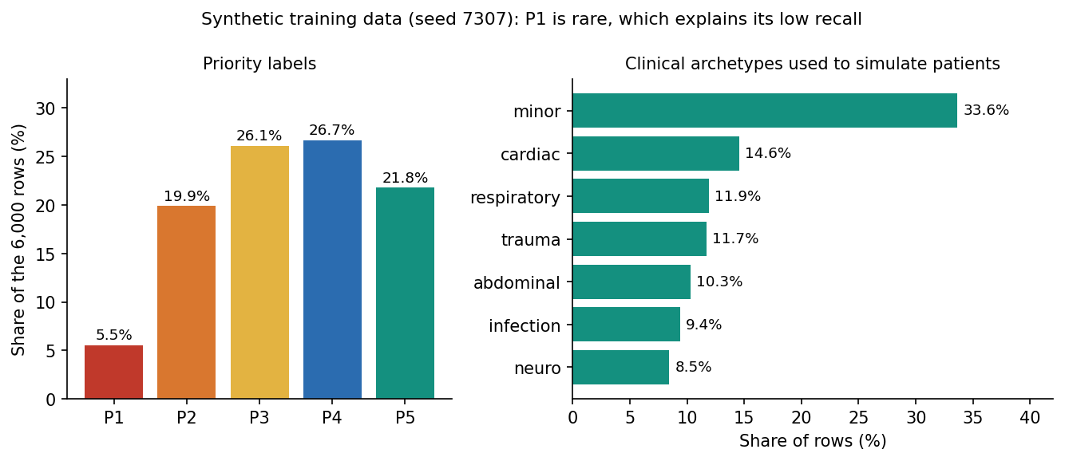
Figure 2: Distribution of priorities and archetypes in the synthetic dataset.

1.2.4 Splits and sample reports
The data is split with stratification on the priority: 80% training pool and 20% test (1,200 cases), then the training pool is split 80/20 into 3,840 rows for fitting the model and 960 rows for fitting the calibrator. The test cases are never used for fitting or calibration. Twelve sample reports (eight two-page PDFs and four PNG scans, scripts/make_sample_reports.py) were generated with the same seed and are stored with the flags and vitals a correct reading must find; they are used for the demonstration and to test the reader, and they are written in the vocabulary of the lexicon, which makes them an easy test.

1.3 Preprocessing and fusion

1.3.1 Reading the report
A PDF page is read with its text layer (pypdf); a page with fewer than 20 characters is treated as a scan and its first embedded image is sent to OCR. An image upload is sent to OCR directly. The OCR engine is RapidOCR, which runs PaddleOCR-family text detection and recognition models on ONNX Runtime [23]: it is installed as one Python package, needs no separate download and no network. Images with a longer side under 2,000 pixels are enlarged by 1.6, and the recognised boxes are sorted into lines and then left to right. Lines that were wrapped mid-sentence (45 characters or more and no closing punctuation) are re-joined, and the text is split into sentences.
Table 5: The report lexicon: 22 text flags in three groups
Group | Flags (examples of phrases matched)
Symptoms (11) | chest pain (chest pressure, tightness, angina); shortness of breath (dyspnoea, breathless, SOB); altered mental state (confusion, drowsy, lethargic, unresponsive); syncope (collapsed, passed out); fever (febrile, chills, rigors); abdominal pain; bleeding (haematemesis, melaena, haematuria); stroke signs (facial droop, slurred speech, one-sided weakness); severe headache (worst, sudden, thunderclap); vomiting; trauma (fall from, road traffic, laceration, head injury)
Findings (5) | ST elevation (STEMI); lung infiltrate (consolidation, pneumonia, effusion); fracture; free abdominal fluid; intracranial haemorrhage (subdural, subarachnoid)
History (6) | diabetes (T2DM, DM2); hypertension (HTN); cardiac disease (CAD, prior MI, heart failure, atrial fibrillation, stent, CABG); COPD or asthma; prior stroke (TIA); anticoagulant (warfarin, apixaban, clopidogrel, heparin)

Each sentence is tested against all 22 expressions. Two rules reduce false matches. A match is discarded when a negation word (no, denies, denied, without, negative for, absence of, not, nil, free of, ruled out) occurs within 45 characters before it in the same sentence, so "denies chest pain" produces nothing. A bleed described as intracranial, subarachnoid, cerebral or subdural is recorded as the finding haemorrhage on CT and not as the symptom bleeding. Spaces inside phrases match zero or more white-space characters because OCR often drops them ("shortnessofbreath"). Every item keeps the page it came from.
Table 6: Lab values read from the report
Lab | Abnormal when | Unit
Troponin | above 0.04 | ng/mL
Lactate | above 2.0 | mmol/L
White cell count | above 11.0 | x10^9/L
Glucose | below 70 or above 250 | mg/dL
Creatinine | above 1.3 | mg/dL
Haemoglobin | below 10.0 | g/dL

A lab is recognised by its name followed by a number; repeated readings of the same lab on the same page are listed once, and an abnormal value sets the lab flag. The result of reading is the 28 flags (22 text flags and 6 lab flags) together with the list of items, labs and pages shown to the nurse.

1.3.2 Fusion with the vitals
The fused record is a vector of 36 numbers in a fixed order that features.py defines for training, serving and the tests: age, heart rate, systolic pressure, diastolic pressure, SpO2, temperature, respiratory rate and the arrival code (walk-in 0, transfer 1, ambulance 2), followed by the 28 flags, each 0 or 1. A flag the report does not mention is 0; there is no imputation, as in the base paper. Vitals are validated on entry (age 0-120, heart rate 20-250, systolic 40-300, diastolic 20-200, SpO2 50-100, temperature 30-44 degrees Celsius, respiratory rate 4-70). Tree models are invariant to monotone rescaling, so the vitals are used unscaled.

1.4 Algorithm choice and justification
Eight classifiers were trained on the same 3,840 fitting rows and scored on the same 1,200 test cases (all on the synthetic data), in the spirit of the base paper's comparison of 19 algorithms [1]. The shipped model is XGBoost with isotonic calibration; the table gives the uncalibrated XGBoost so that the comparison is like for like.
Table 7: Eight models on the same split (synthetic hold-out)
Model | Accuracy | Within one | Macro F1 | QWK | Top-2
Logistic regression | 72.4% | 99.7% | 0.727 | 0.897 | 96.4%
Decision tree | 54.7% | 94.7% | 0.530 | 0.761 | 80.5%
Random forest | 67.2% | 99.7% | 0.623 | 0.871 | 95.1%
Extra trees | 69.1% | 99.2% | 0.653 | 0.872 | 94.3%
k-nearest neighbours | 62.6% | 97.8% | 0.564 | 0.830 | 89.2%
MLP | 70.9% | 99.3% | 0.701 | 0.888 | 97.2%
HistGradientBoosting | 70.3% | 99.6% | 0.669 | 0.884 | 95.6%
XGBoost (shipped config) | 68.2% | 99.7% | 0.653 | 0.877 | 95.5%

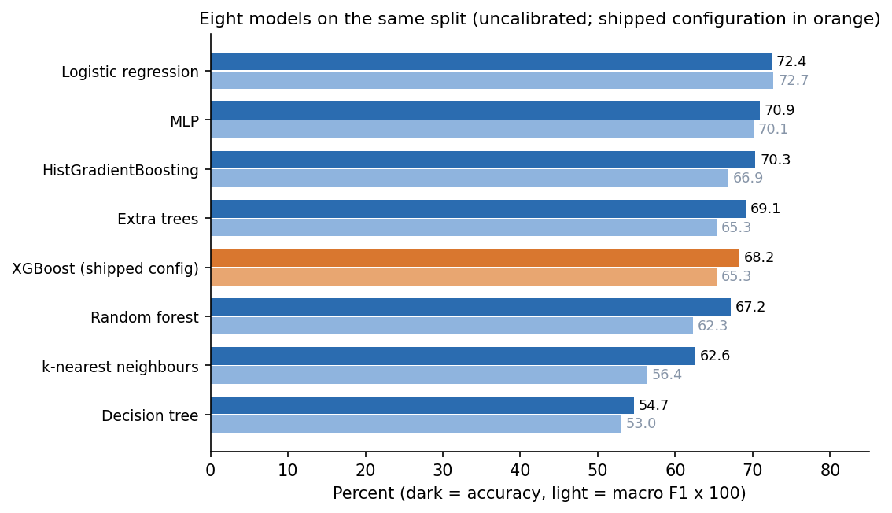
Figure 3: Accuracy and macro F1 of the eight models on the synthetic hold-out.
The result does not favour the shipped model. Logistic regression is the most accurate (72.4%) and XGBoost sits in the middle (68.2%); five-fold cross-validation on all 6,000 rows gives 71.6% for logistic regression, 71.1% for the random forest and 72.4% for XGBoost, with standard deviations of one to two points, so the three are close. The reason is in the data: the labels come from an additive severity score, which a linear model recovers almost exactly. The single decision tree (depth 8) and k-nearest neighbours are clearly worse.
XGBoost was kept for four reasons, and only the first three are supported by this study. (1) It gives probabilities that can be calibrated and used as a confidence. (2) SHAP's tree explainer computes exact attributions for it in milliseconds [17]. (3) It handles the 0/1 flags and the numeric vitals without scaling. (4) On real tabular data tree ensembles usually keep an edge over linear and neural models [21]; this is an assumption carried over from the literature, not something this study showed, and with real records the choice should be repeated.
Table 8: Value of fusing the two sources (XGBoost, same split)
Inputs | Count | Accuracy | Within one | Macro F1 | Top-2
Vitals only (8) | 8 | 40.6% | 82.2% | 0.367 | 70.3%
Report only (28) | 28 | 63.2% | 97.2% | 0.615 | 92.2%
Fused (36) | 36 | 68.2% | 99.7% | 0.653 | 95.5%
Vitals + text flags (30) | 30 | 61.5% | 96.9% | 0.577 | 89.7%
Vitals + lab flags (14) | 14 | 46.9% | 87.9% | 0.429 | 77.8%

The ablation measures the gap named in the literature survey. Vitals alone reach 40.6%, the report alone 63.2% and the fused record 68.2%: fusion adds 27.7 points over vitals alone and 5.1 over the report alone. Because the synthetic severity rule puts large weights on report flags, the size of the gain is partly a property of the generator, but its direction is what the design assumed.
Two components named in the batch abstract were not built. BioBERT would replace the lexicon with a learned reader [22]; it needs labelled clinical text that was not available and a GPU-class model on a CPU-only workstation. Retrieval-augmented generation and a multi-agent orchestration (the companion paper [6]) were left as future work.

1.5 Mathematical formulation
Let x in R^36 be the fused record and K = 5 the number of priorities. XGBoost builds an additive model of regression trees, one score per class:
F(x, k) = Σ f(t, k; x) over t = 1 … 220, p(k | x) = exp F(x, k) / Σ exp F(x, j) over j = 1 … 5 (2)
Each tree f(t, k) is a function of depth at most 4 that is fitted greedily to the gradient of the multi-class log loss, with learning rate 0.1, row sampling 0.9 and column sampling 0.9 [15]. The softmax gives raw probabilities p(k | x), which are usually too confident or not confident enough. Calibration learns, for every class, a non-decreasing function g(k) on a separate split by isotonic regression [18], and the calibrated probabilities are renormalised:
g(k) = non-decreasing map that minimises Σ [ 1(y = k) − g(p(k | x)) ]² over the calibration rows; q(k | x) = g(p(k | x)) / Σ g(p(j | x)) over j (3)
The priority, the confidence and the risk level follow directly:
priority(x) = 1 + argmax over k of q(k | x); confidence(x) = max over k of q(k | x); risk = High if priority ≤ 2, Moderate if priority = 3, Low otherwise (4)
The explanation is a Shapley attribution [16, 17]. For the chosen class k, the score F(x, k) is decomposed into a base value and one contribution per input, and the contributions are listed in descending absolute value:
F(x, k) = φ0 + Σ φi over i = 1 … 36, φi = Σ over S ⊆ N∖{i} of [ |S|! (36 − |S| − 1)! / 36! ] · [ F(S ∪ {i}, k) − F(S, k) ] (5)
A positive φi raises the score of the chosen priority and a negative one lowers it (the API words this as raises or lowers urgency, which reads the wrong way round when the chosen priority is 4 or 5; see Chapter 7). The explainer attributes the uncalibrated tree scores, so the bars explain the model's raw preference for a priority, while the confidence shown beside them is the calibrated probability. The metrics used in Chapter 8 are defined as follows, with n test cases, true priority y_i and predicted priority a_i:
accuracy = (1/n) Σ 1(a = y); within-one = (1/n) Σ 1(|a − y| ≤ 1); macro-F1 = (1/5) Σ F1(k) over k = 1 … 5 (6)
QWK = 1 − Σ w(i,j) O(i,j) / Σ w(i,j) E(i,j), w(i,j) = (i − j)² / 16; ECE = Σ ( |Bm| / n ) · | acc(Bm) − conf(Bm) | over bins m (7)
The quadratic weighted kappa (QWK) compares the observed confusion matrix O with the matrix E expected by chance and penalises a miss by the square of its distance, which suits an ordinal scale; the expected calibration error (ECE) groups predictions into ten confidence bins Bm and measures the gap between confidence and accuracy [20].

1.6 Model architecture and training configuration
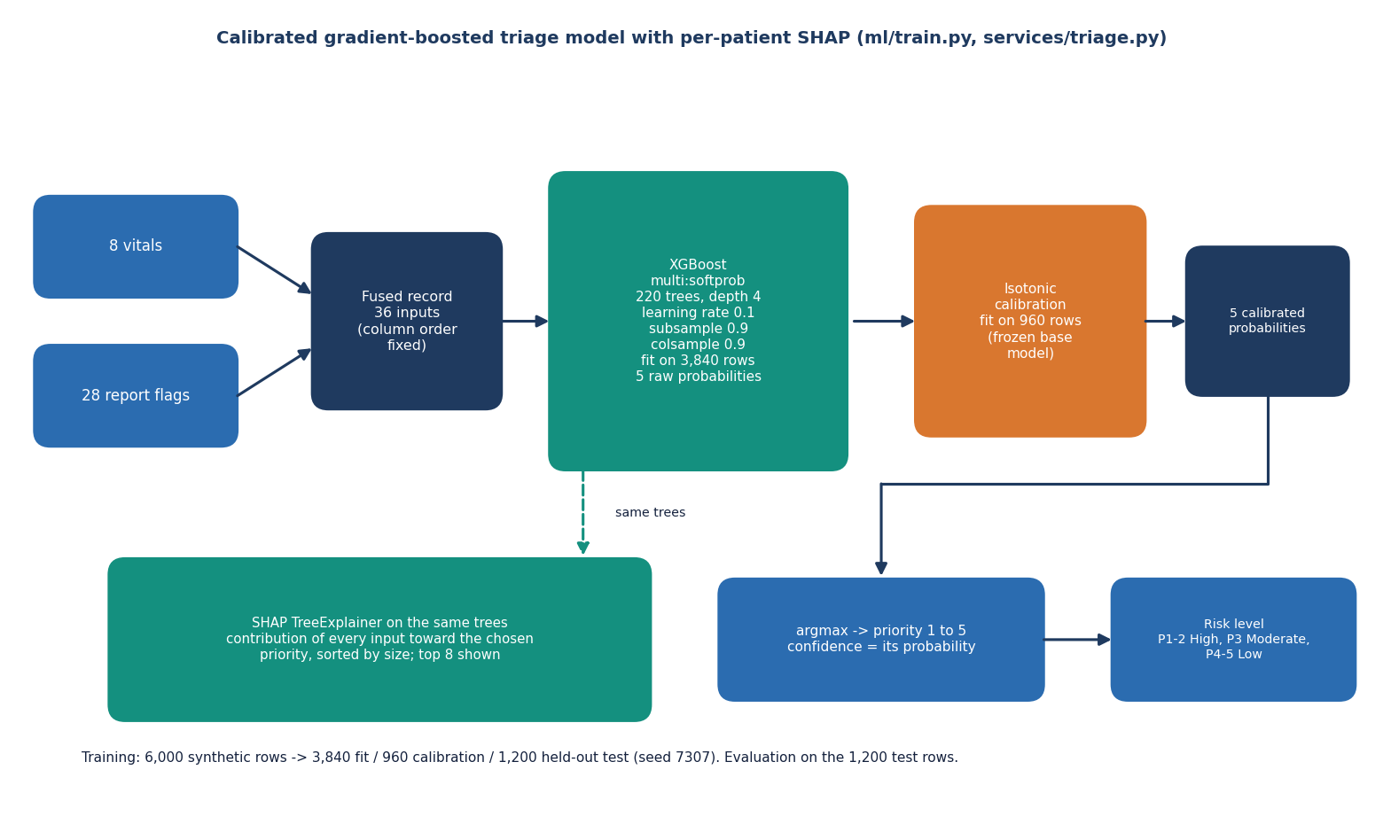
Figure 4: Architecture of the triage model: fused record, XGBoost, isotonic calibration, arg-max, SHAP.
Table 9: Training configuration (ml/train.py)
Item | Value
Inputs / classes | 36 / 5 (priorities 1 to 5)
Rows: fit / calibration / test | 3,840 / 960 / 1,200 (stratified, seed 7307)
Classifier | XGBClassifier, objective multi:softprob, eval metric mlogloss
Trees / depth / learning rate | 220 / 4 / 0.1
Row and column sampling | 0.9 and 0.9
Calibration | CalibratedClassifierCV(FrozenEstimator(base), method="isotonic") fitted on the calibration split
Explainer | shap.TreeExplainer on the base trees
Training time (CPU) | 0.44 s
Model time per patient | about 0.012 ms in a batch of 1,200; 21.7 ms median for the whole POST /patients request including SHAP
Hardware | Intel Core i5-12500 (12 threads), 15.7 GB RAM, Windows 11 Pro, no GPU, Python 3.11.9, Node 24.19.0
Libraries | scikit-learn, XGBoost, SHAP, pandas, NumPy (Python 3.11)

No hyper-parameter search was run: the configuration is the first reasonable setting, as the dataset is small and the labels are noisy. The base paper tuned each of its 19 models with 100 Optuna trials [1]; doing the same here is listed as future work.

1.6.1 Shipped model on the synthetic hold-out
On the 1,200 held-out synthetic cases the shipped model reaches an accuracy of 69.42%, a within-one accuracy of 99.67%, a macro F1 of 0.670, a quadratic weighted kappa of 0.880 and a top-2 accuracy of 95.3%. Recall for priorities 1 to 5 is 44% / 54% / 73% / 72% / 83%. Almost every error is a neighbouring priority, and the sickest class is the hardest. The full results, with the confusion matrix, are in Chapter 8.

1.6.2 Calibration and confidence
Isotonic calibration lowers the expected calibration error from 0.0466 to 0.0412 and the multi-class Brier score from 0.4187 to 0.4104: a modest gain. The mean confidence rises from 0.646 to 0.732, close to the accuracy of 69.4%. Confidence is informative: predictions with a confidence of at least 0.70 cover 58.8% of cases and are right 78.2% of the time, and at 0.85 (the threshold the base paper uses [1]) they cover 25.5% of cases at 87.6% accuracy. The product shows the confidence to the clinician; it does not yet use a threshold to route cases.

1.6.3 Handling a report that is read badly
A reading error reaches the model as a missing flag. To measure the cost, each positive flag was removed at random with a given probability before scoring the test set. Accuracy falls from 69.4% to 66.2% at 10% dropped and 59.5% at 30% dropped, and to 33.9% with no report at all; within-one accuracy is still 95% at 30% lost. The reader's recall on the hand-written stress set (84.3%) therefore puts the system in the region where one report finding in six is missed, which the evaluation chapter reports as a limitation.

1.6.4 Stability of the estimates
The shipped split (seed 7307) is a slightly unlucky one: with five other split seeds the same recipe gives a mean accuracy of 71.6% with a standard deviation of 0.9% and a mean macro F1 of 0.682, against 69.4% and 0.670 for the shipped split. The headline figures in the product are those of the shipped split, and this report quotes them as they are.

2. NOVELTY AGAINST THE BASE PAPER

2.1 What the base paper contributes
The base paper [1] studies diagnostic classification under incomplete clinical data. It takes 1,655 real clinical cases (internal medicine 616, paediatrics 1,039), each described by binary indicators of symptoms, examination findings and a few laboratory results (up to 479 parameters), and maps them to ICD-10 diagnostic classes (87 classes). It compares 19 classifiers tuned with Optuna (100 trials per model), reports a two-stage TOP-1 / TOP-3 evaluation that formalises differential diagnosis, and adds a confidence threshold of 0.85 for accepting the first diagnosis, with SHAP and LIME to explain the best models. Gradient Boosting scores 84.74% in internal medicine and the multi-layer perceptron 87.20% in paediatrics; on 120 external cases TOP-1 accuracy is 73.33% and 78.33%. A symptom absent from the record is treated as absent, with no imputation. The paper's own text states the limits that matter here: typed indicators only (no scans, no free text), diagnosis rather than urgency, and two specialties from one region.

2.2 What ATHENA adopts from the base paper
• The principle of treating an unrecorded finding as absent rather than imputing it; ATHENA sets every unreported flag to 0.
• Comparing several algorithm families on the same split before choosing one (eight here, nineteen there).
• Reporting a ranked output next to the single best label (Top-2 accuracy here, TOP-3 there) and a high-confidence threshold (0.85 in both).
• Showing SHAP attributions so that a clinician can see why a label was proposed.

2.3 What is new in ATHENA and what is not
Table 10: Novelty against the base paper
Aspect | Base paper | ATHENA | New?
Task | ICD-10 diagnosis, 87 classes | Five-level triage priority and a three-level risk | Different task: not a claim of improvement
Input | Typed binary symptom indicators | Scanned PDF or image read by text layer or local OCR, fused with 8 vitals into 36 inputs | Yes
Models | 19 classifiers, Optuna tuning | 8 classifiers compared; XGBoost shipped without tuning | No: narrower, standard methods
Uncertainty | TOP-1 / TOP-3, 0.85 threshold, entropy | Isotonic-calibrated probabilities, Top-2, confidence-coverage table, risk level | Partly: calibration and risk level added
Explanation | SHAP and LIME, global and by class | Per-patient SHAP beside the decision, plus global importance | Per-patient view in the workflow is new; LIME not built
Missing input | No imputation; absent = 0 | Same rule, plus a dropped-flag experiment: accuracy 66.2% at 10% dropped, 33.9% with no report | Measured, not new
Human in the loop | Not part of the study | Accept or change with a reason, stored with the case; queue reorders | Yes
Time per patient | Not reported in the paper | Median 30 ms for a PDF and 2.1 s for a scan, read plus triage, over HTTP | Yes
Data | 1,655 real cases and 120 external cases | 6,000 seeded synthetic cases; no real patient data | Weaker: the main limitation

2.4 Why the integration counts
The literature survey of this batch found one gap: the surveyed models are evaluated on single-modality structured data, and nothing fuses a scanned report with the vitals while showing the reasons for the decision. ATHENA closes that gap as a working pipeline and measures what fusion is worth on its data. With the same classifier, vitals alone reach 40.58% accuracy, the report alone 63.17% and the fused record 68.25%, a gain of 27.7 points over vitals and 5.1 over the report. This is a property of how the synthetic labels were built as much as of the model, and it must be read that way, but it is the measurement the single-modality studies in the survey cannot make.
A second contribution is negative and easy to overlook: the same code shows that a linear baseline (72.42%) beats the shipped XGBoost (68.25% uncalibrated), because the synthetic labels come from an additive severity score, and that the exact accuracy of any model is capped near 86.25% by the label noise. Reporting this is part of the method.

2.5 Where this work is weaker than the base paper
• No real patient data. The base paper uses real records and an external validation set; ATHENA's figures describe how well a model recovers a known rule.
• A narrower model study: no hyper-parameter search, eight classifiers instead of 19, no significance tests.
• No medical language model. The batch abstract named BioBERT; the report reader is a lexicon, and LIME, RAG and multi-agent orchestration were not built.
• The comparison with the paper is therefore indicative at most: different task, different classes, different data.

3. KEY CONTRIBUTIONS
The work makes the following contributions.
1. A working triage pipeline. A PDF or scanned report is read (text layer, or local RapidOCR for images), parsed into 22 clinical flags and 6 laboratory flags with negation handling, fused with eight vitals into 36 inputs, and turned into a priority from 1 to 5, a risk level and a confidence.
2. A calibrated, explained decision. XGBoost with isotonic calibration (ECE 0.047 to 0.041) gives the priority; per-patient SHAP lists the strongest drivers, strongest first, next to every decision.
3. A clinician-in-the-loop record. Accept or change with a reason, stored with the case and the model's original suggestion; the queue reorders by priority then arrival; a triage-summary PDF can be downloaded.
4. A measured fusion gain. On the synthetic hold-out, fused inputs reach 68.25% exact accuracy against 40.58% for vitals only and 63.17% for the report only.
5. An honest evaluation. Eight-model comparison, 5-fold and five-seed stability, a noise ceiling of 86.25%, calibration, confidence-coverage, under- and over-triage, dropped-report robustness, global SHAP, and a 40-fragment stress test of the reader.
6. Measured cost per patient. Median 30 ms for a PDF report and 2.1 s for a scanned image, from upload to priority, over HTTP on a CPU-only machine.
7. Reproducible tooling. Seeded data generator, training, evaluation, experiment, latency and screenshot scripts, 47 automated tests (46 passing, 1 documented expected failure) and 17 smoke checks; every figure in the documents is generated from stored JSON.
None of these contributions is a new algorithm; they are integration, measurement and honest reporting around standard components. All model figures are on seeded synthetic data.

